Python Environment Setup:

1. Download the latest python distribution from

<https://www.python.org/downloads/>

1. Install The python

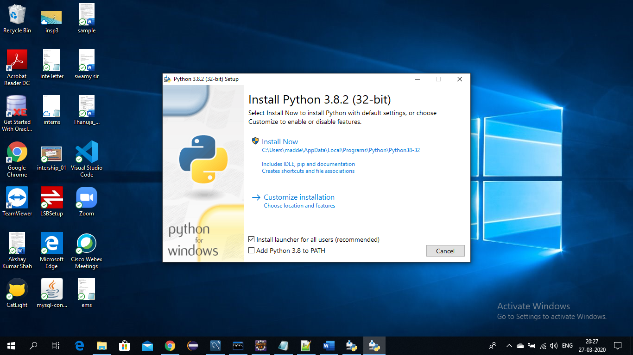

Select the path

By default python will be installed on

C:/users/madde/AppData/Local/Programs/python/pythom8.2

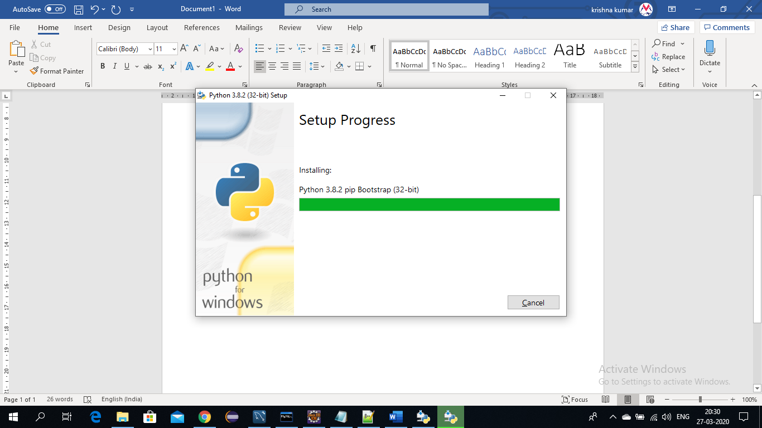

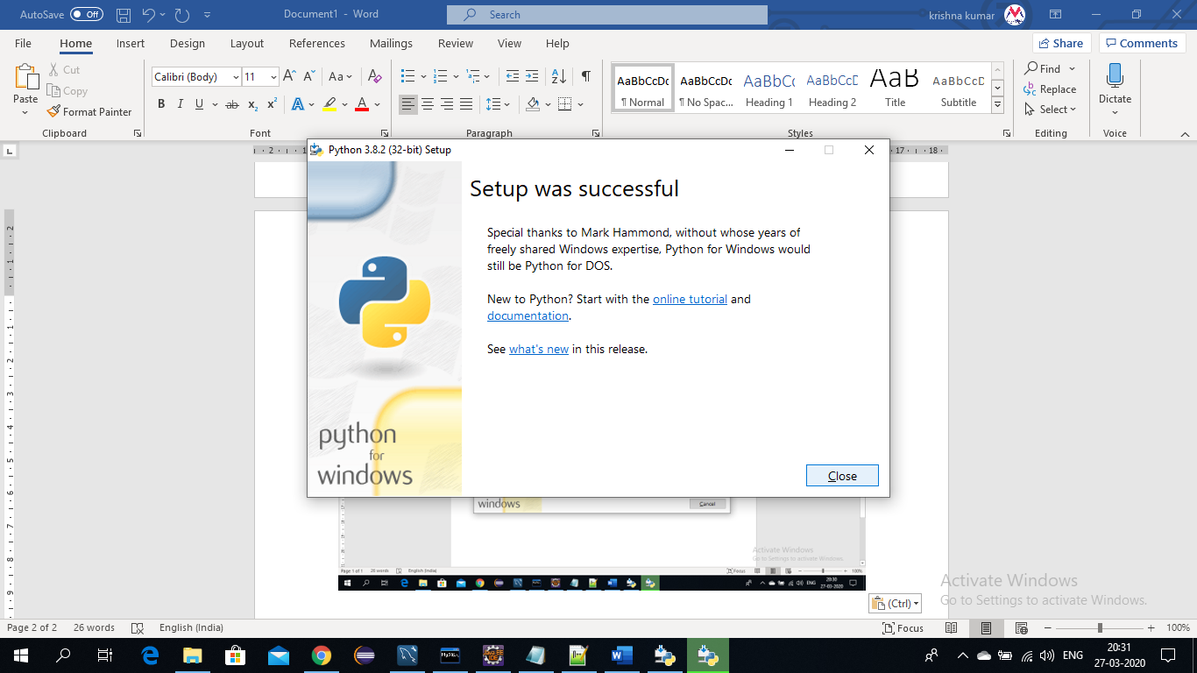

Set The Path

Check the Version

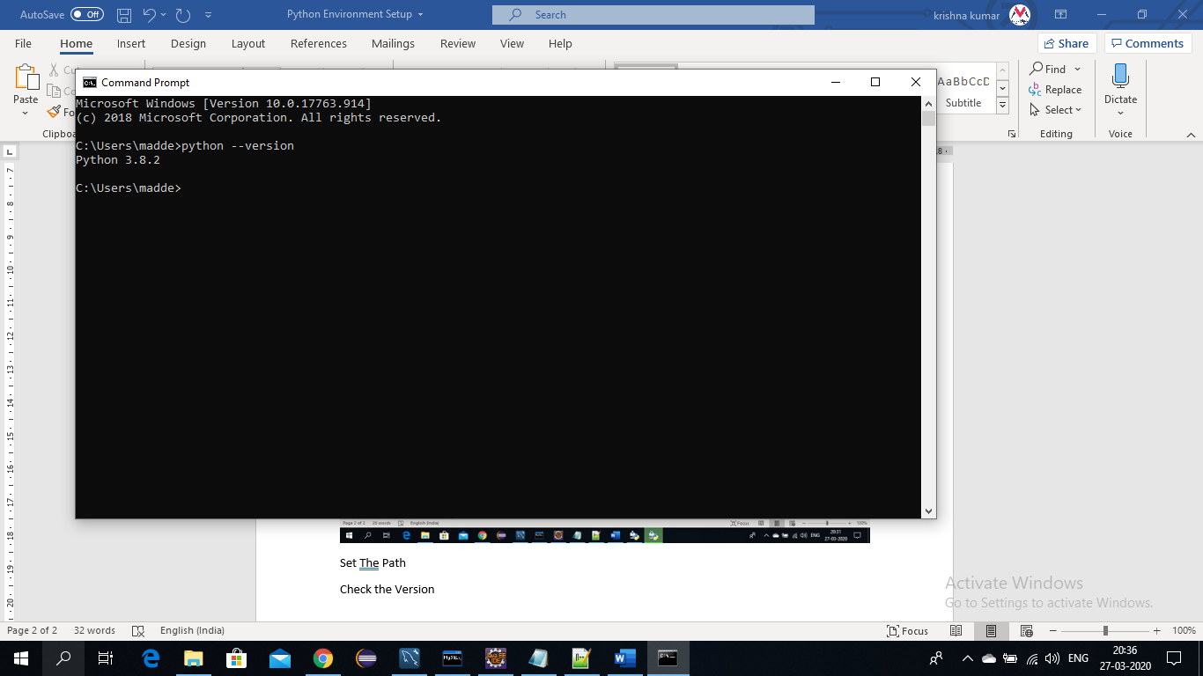

1. Easy to Learn and Use
2. Expressive Language //
3. Interpreted Language
4. Cross-platform Language
5. Free and Open Source
6. Object-Oriented Language
7. Large Standard Library
8. GUI Programming Support( transfer - )
9. Integrated

It can be easily integrated with languages like C, C++, JAVA etc.